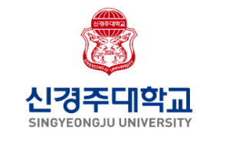
Graduate Application Form for
International Students

1. Desired Program of Study |  |  |  | Application No.  (For office use only)
Entrance Year |  | Entrance Semester | □ March □ Fall |  | 
Desired program of study | □ Master's □ Doctoral □ Combined master's and doctorate
Department/ Major

2. Student Information
Name  (in Korean) |  |  |  |  | Name  (in English)
Name  (in Korean) |  |  |  |  |  |  | (as written on the passport)
Date of Birth  (YYYY/MM/DD) |  |  | Nationality |  |  |  |  | Gender |  | □  □ | Male  Female
Passport No. |  |  |  |  | Alien registration number
Telephone No. |  |  |  |  |  | E-mail
Emergency contact info. | Full Passport Name |  |  |  |  | Relationship to applicant
Emergency contact info. | Contact Number

3. Educational Background
University where the last degree was awarded | Name of School |  | Address
University where the last degree was awarded | Major
University where the last degree was awarded | Academic Status | □ Graduated  □ Expected to Graduate | (Expected) Graduation  Date
4. Proof of Language Proficiency
Korean | TOPIK ( □ Level 3 □ Level 4 □ Level 5 □ Level 6)  Other ( □ SKA □ Sejong Institute )
English | □ TOEFL 530(CBT 197, iBT 71) or higher  □ CEFR B2 or higher | □ IELTS 5.5 or higher  □ TEPS 601(NEW TEPS 327) or higher

5. A Certification of Responsibility for Tuition Fee and Living Expenses
■ Financial Sponsor’s Information
Name |  | Relationship |  | Occupation
Address |  |  |  | Telephone No.
Place of  Employment |  |  |  | Department /  Position
Employment Address |  |  |  | Contact No.
I hereby guarantee to cover any expenses accrued by the applicant for the duration of study.
Date Signature of Sponsor
6. Personal Statement
7. Cover Letter & Study Plan
(1) Describe your motivation for entering the school.
(2) Describe your research plan.
(3) Describe your plan after graduation.
(4) List any additional comments.
I declare that all the information provided in this statement is true and accurate. If any information is found to be false, I acknowledge that my application or admission may be denied or revoked at any time.

Applicant’s Signature

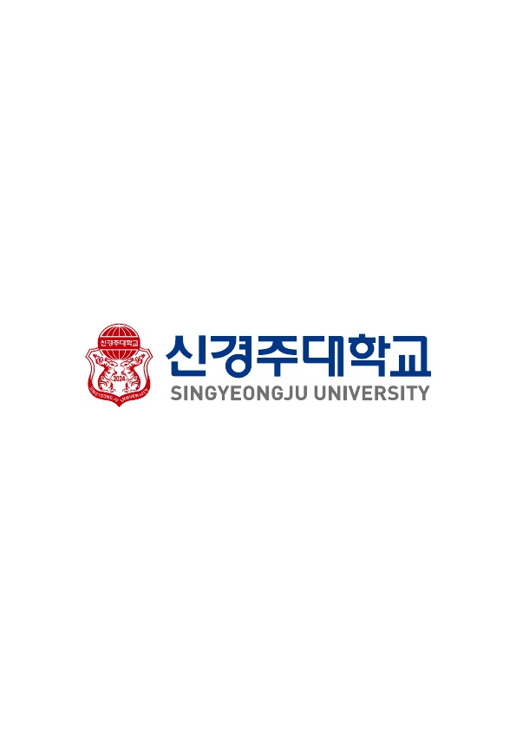
유학경비 부담 서약서
Certification of Financial Support for International Students

I. 지원자 인적사항(Applicant Information)
1. 이름 (Name in Full) : __________________________________________
2. 출생국(Country of Birth) : _________________________________
3. 국적(Nationality) : ________________________________________
4. 성별(Gender) : ( )남(Male) ( )여(Female)
5. 생년월일(Date of Birth) : ______일(DD)/______월(MM)/_________년(YYYY)
6. 지원학과(Department which you are applying) : _______________________________________
7. 주소(Address) : _________________________________________________________________ __
전화(Phone Number) : ___________________________________
E-Mail 주소(E-Mail Address) : ____________________________________
8. 여권번호(Passport No) : ____________________________________________

II. 유학경비를 부담할 개인 또는 기관(Financial Information)
(Indicate the person(including yourself) or organization that will be responsible for
your tuition fee and living expenses)
◦ 개인 또는 기관명(Name of Financial Sponsor) :_______________________________________
◦ 관계(Relationship) : __________________
◦ 생년월일(Date of Birth) : ______일(DD)/______월(MM)/_________년(YYYY)
◦ 직업 : 개인일 경우(Occupation) : ___________________________
◦ 주소(Address) :___________________________________________________________________
◦ 전화번호(Tel) : ____________________________
◦ 휴대폰번호(Cell) : __________________________

본인은 상기 지원자의 유학기간 중 신원보증을 약속하며 일체의 경비부담을 서약합니다.
I guarantee that I will be responsible for above-named applicant's tuition fee and living expenses and student reference for the duration of the whole program.

◦ 날짜(Date) : ______일(DD)/______월(MM)/_________년(YYYY)
◦ 이름(Name of Sponsor) : _________________________
◦ 서명(Signature) : ______________________

신경주대학교 총장 귀하
To the President of Singyeongju University
신입학 외국인유학생 사유서
Statement of Reasons for Issues Requiring Further Clarification
구 분  Type | □ 한국어학당  Korean Language Institute  □ 학부 Undergraduate  □ 대학원 Graduate | 지원학과(부)  Desired Department
성 명  Full Name |  | 생 년 월 일  Date of Birth
사유 Reason
□ 학기 결손 / 학기 중복  Missing semesters / Repeated semesters  □ 월반 Skipped grade  □ 조기 졸업 Early graduation |  | □ 학기 중 해외 체류 (15일 이상)  Staying abroad during semester(over 15 days)  □ 병으로 인한 결석  absence due to illness  □ 기타 Other
■ 사유서에 기재한 내용을 증명할 수 있는 증빙자료 제출 : 해당 학교(기관)에서 발급한 공식서류
The stated reasons must be supported with proof documents by the relevant institution to support your claim
위 기재 내용은 틀림이 없으며, 만약 허위 기재 사실이 확인되었을 경우 합격 또는
입학 허가가 취소될 수 있음을 인지합니다.
I declare that all the information provided in this statement is true and accurate. If any information is found to be false, I acknowledge that my application or admission may be denied or revoked at any time.

______일(DD)/______월(MM)/_________년(YYYY)

서명 Signature ______________________

신경주대학교 총장 귀하
To the President of Singyeongju University
개인정보 수집·이용 및 제3자 제공 동의서
귀하께서 제공하신 개인정보는 학부 원서접수 및 학부 전형을 위해 이용하고 있고, 이외의 다른 목적에는 사용되지 않습니다.

▪ 개인정보 수집항목
- 이름, 주소, 전화번호, 휴대전화번호, 이메일, 추가 연락처, 모집단위, 학교정부(최종학력 구분,
재학, 출신 고등학교명, 대학명, 졸업(예정) 연도, 자기소개서 등 전형에 필요한 정보
▪ 개인정보의 수집 및 이용 목적 :
- 학부 원서접수 및 대입 전형을 위해 개인정보가 사용됩니다.
- 합격 후 학력조회 및 학사 행정과 관련하여 제3자에게 제공될 수 있습니다.

▪ 개인정보의 보유 및 이용 기간
- 개인정보 보유기간의 경과, 처리목적 달성 등 개인정보가 불필요하게 되었을 때는 지체없이 해당
개인정보를 파기합니다.
▪ 개인정보의 수집 및 이용 동의에 대하여 거부할 수 있으며, 동의 거부 시 원서접수가 불가합니다.
□ 동의함 □ 동의하지 않음
지원자 서명 :
Consent for Collection and Use of Personal Information
The personal information and personally identifiable information provided are used for processing and screening the application. The information provided will not be used for any other purposes. Information such as your name, alien registration number, passport number, address, telephone number, mobile number, email address, applied major, educational background (name of schools/universities, graduation year, etc) personal statement, etc. will be kept confidential.

▪ Collection of personal information
- Full-name, address, telephone/mobile phone number, email address, contacts, fields of study,
school or university information, graduation year, personal statement and so on
▪ Purpose of collection and use of personal information
- Personal information can be used to process the application
- If applicant is admitted, his/her personal information may be provided to a third party in relation to an academic background check and administrative purposes.

▪ Retention and disposal of personal information
- When personal information becomes unnecessary or the personal information retention period
expires, the information will be immediately disposed of.
▪ I understand that I have a right to refuse the collection and use of my personal information.
However, I also understand that my refusal to give my consent may result in my application being
rejected.
□ I agree □ I do not
Applicant's Signature :

